Math 521 HW3

Raj Mohanty

raj.mohanty@student.csulb.edu

**2 Computing**

**2.1 Problem 1**

Here’s the problem statement:

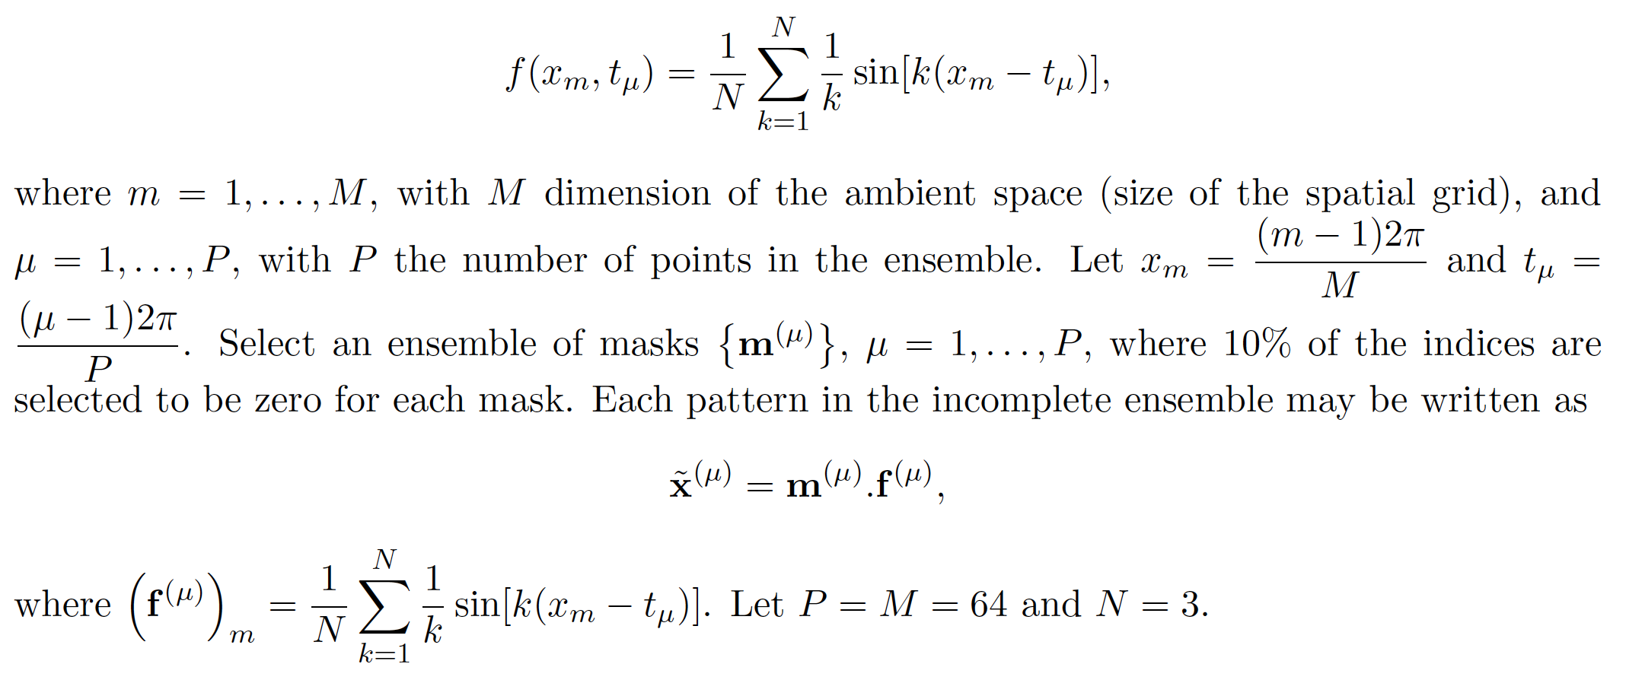

a)

We create the original data as follows (code snippet 2.1.1):

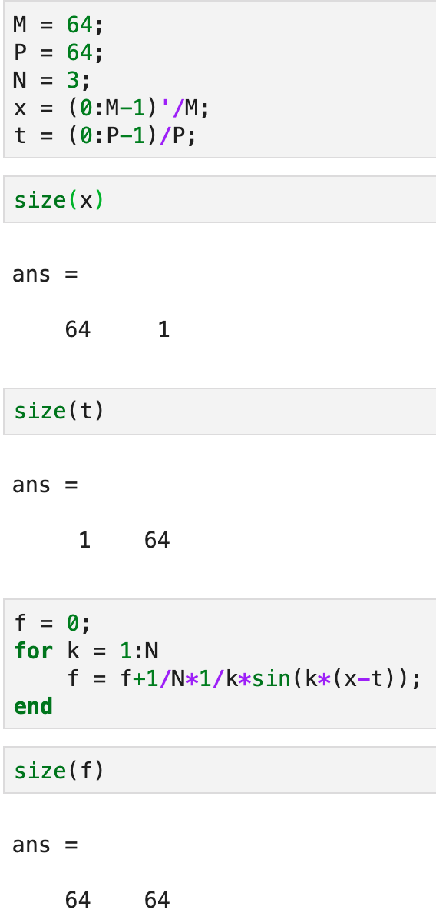

*Code snippet 2.1.1 : Creation of original data*

The 3-D plot of the original data is shown in figure 2.1.1

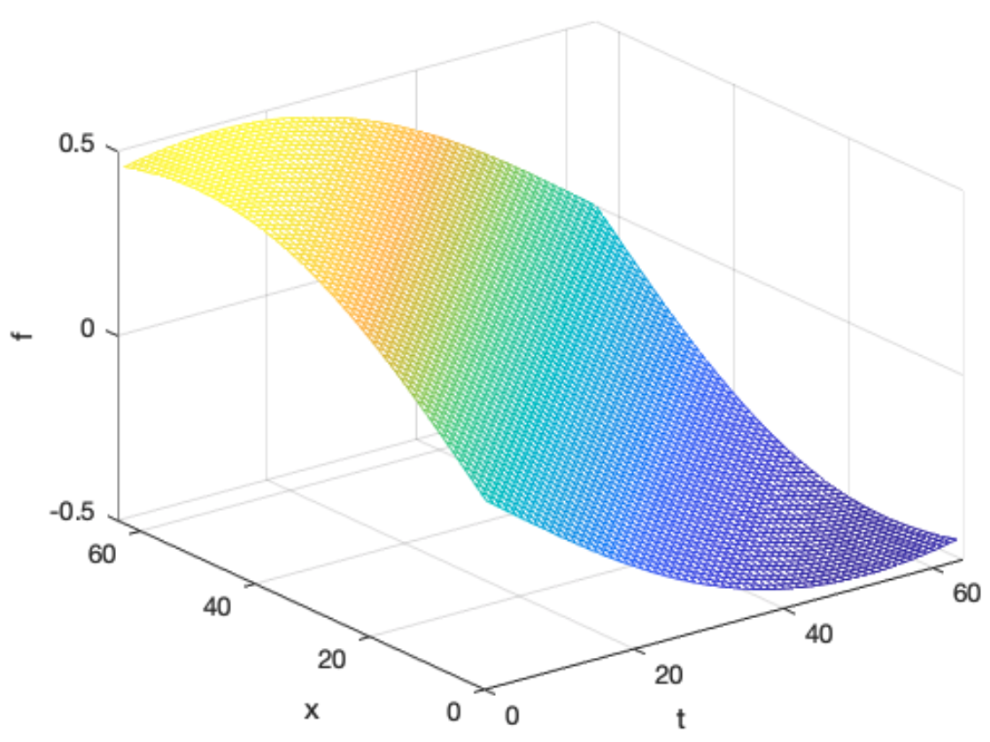

*Figure 2.1.1: 3-D plot of the original data*

The mask for 10% missing data is created as shown in code snippet 2.1.2

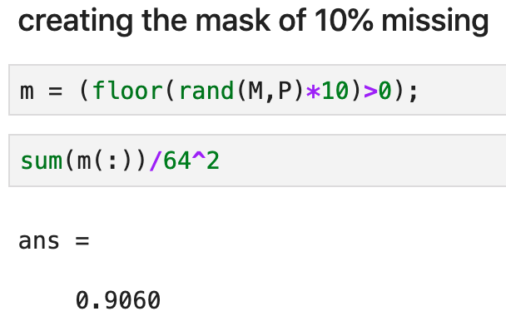

Code snippet 2.1.2: Mask for 10% missing data

Applying the mask to the original data creates the gappy data as shown in figure 2.1.2

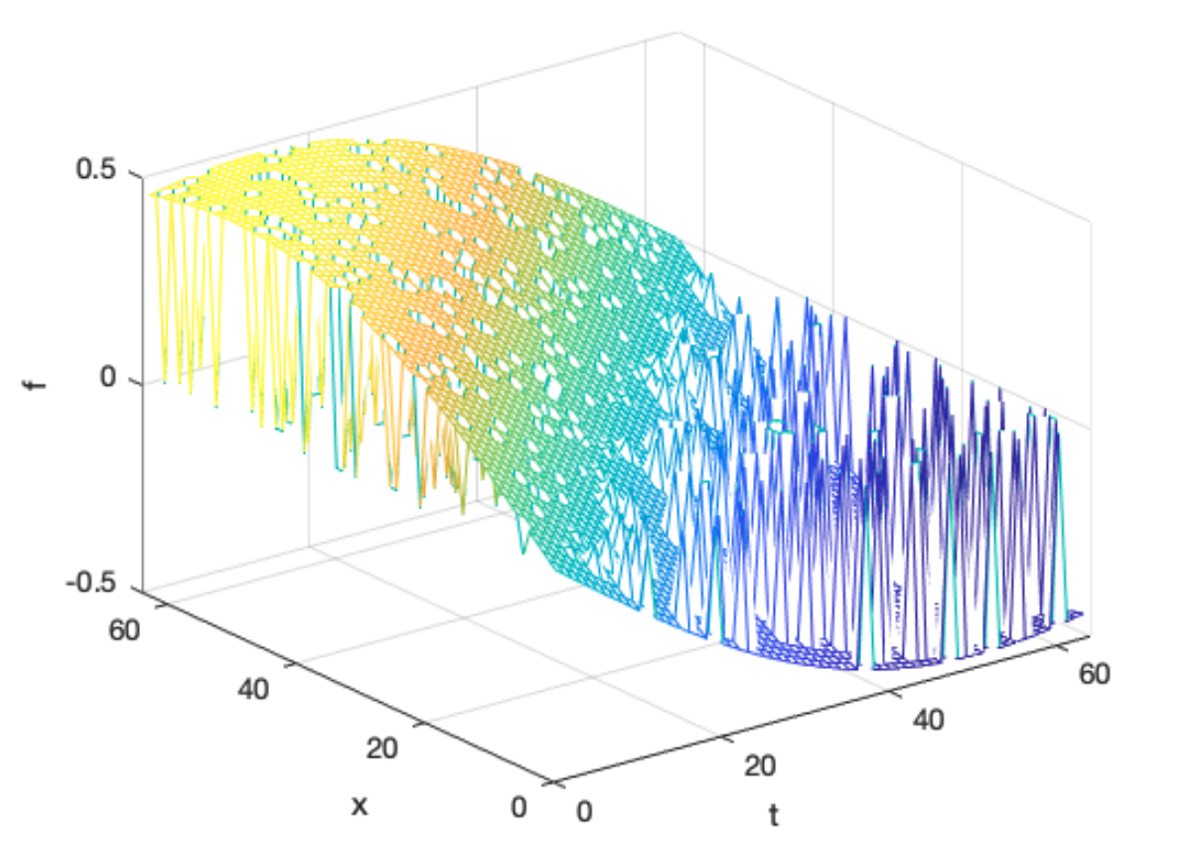

*Figure 2.1.2: 3-D plot of the gappy data*

We then estimate missing by taking ensemble average, bringing the missing values to non-zero values but still rough as shown in figure 2.1.3.

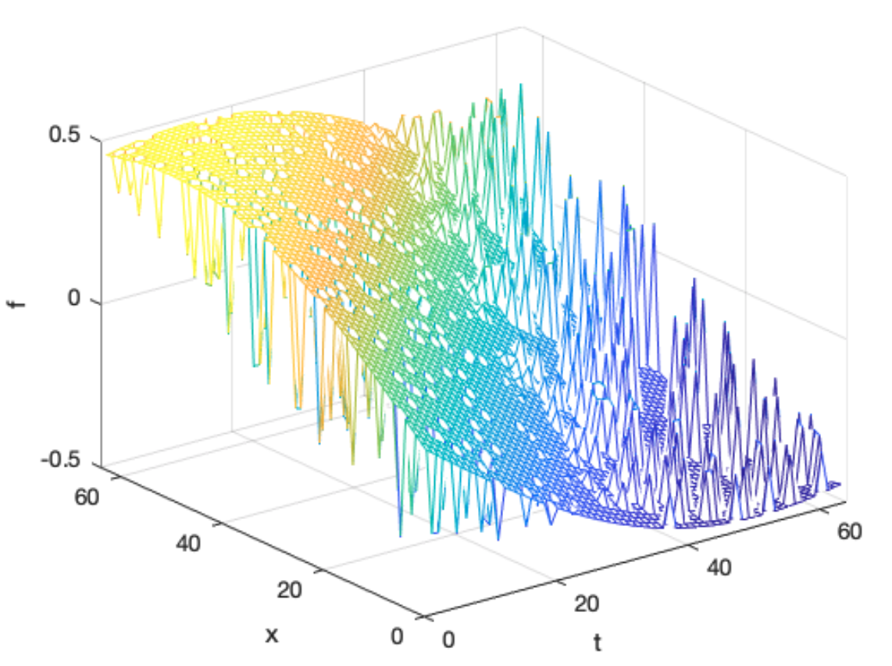

*Figure 2.1.3: 3-D plot of the gappy data with missing values estimated as ensemble average*

We then estimate the KL basis be solving the below eigenvalue problem

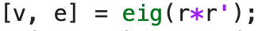

Then we estimate the coefficient ai by doing the following

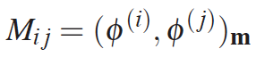

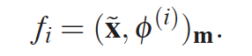

$$\vec{a}=M^{-1}f$$

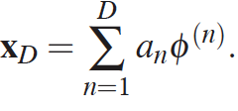

All of this logic is summarized in the following code snippet 2.1.3

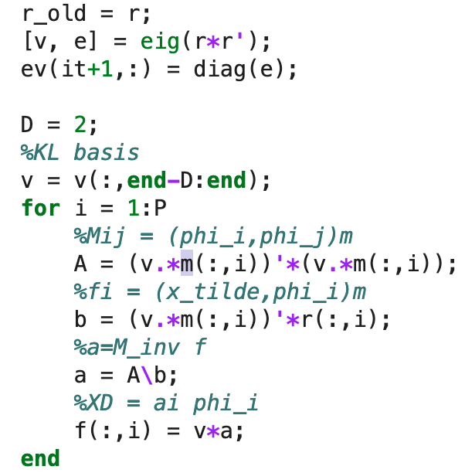

*Code snippet 2.1.3: Steps to get estimate of missing data*

We then run these steps until there is no significant improvement in recovered data over previous iteration.

b) Eigenvalues as a function of iterations

We then plot the first 8 eigenvalues as a function of the iteration

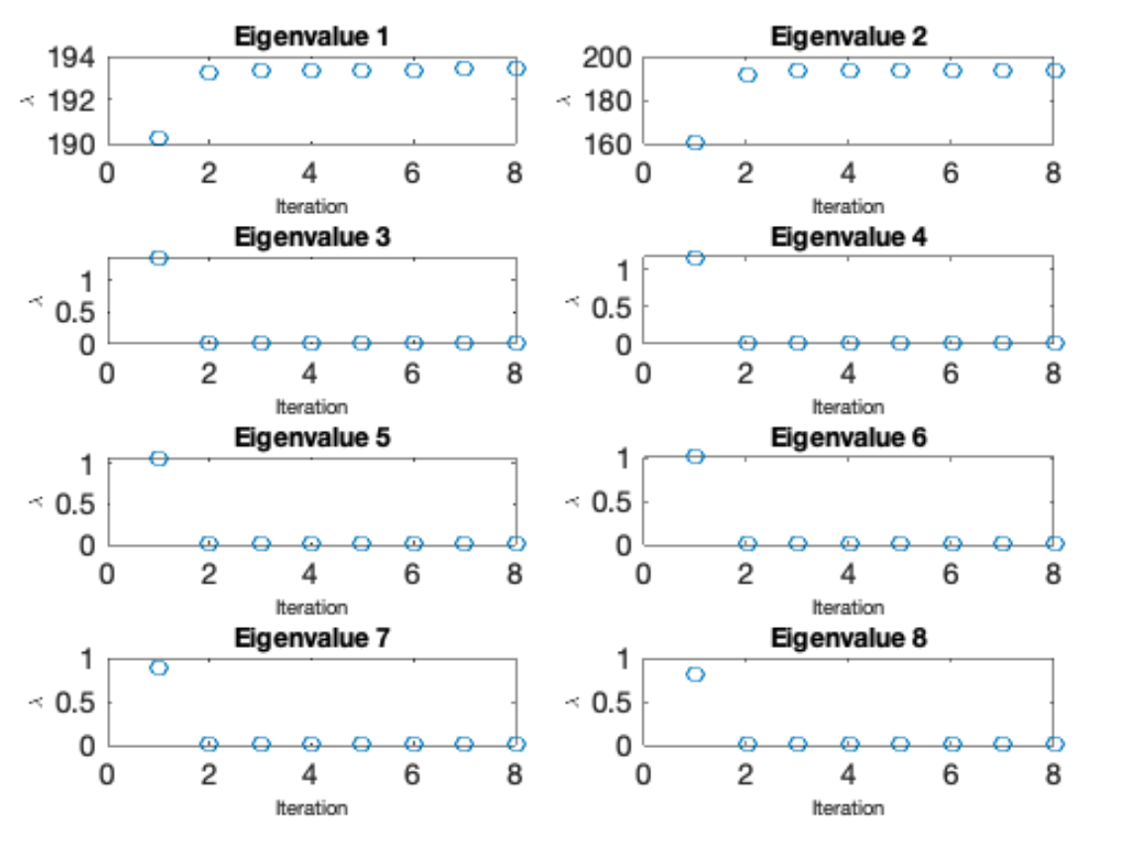

*Figure 2.1.4: Eigenvalues as a function of iteration*

We notice that eigenvalues 1 and 2 are the most significant across the iterations. After the algorithm has converged, we notice that we just need to keep first 3 eigenvalues.

c) Eigenfunctions of the 10 largest eigenvalues

We then plot the first 10 eigenfunctions of the largest eigenvalues after the algorithm has converged.

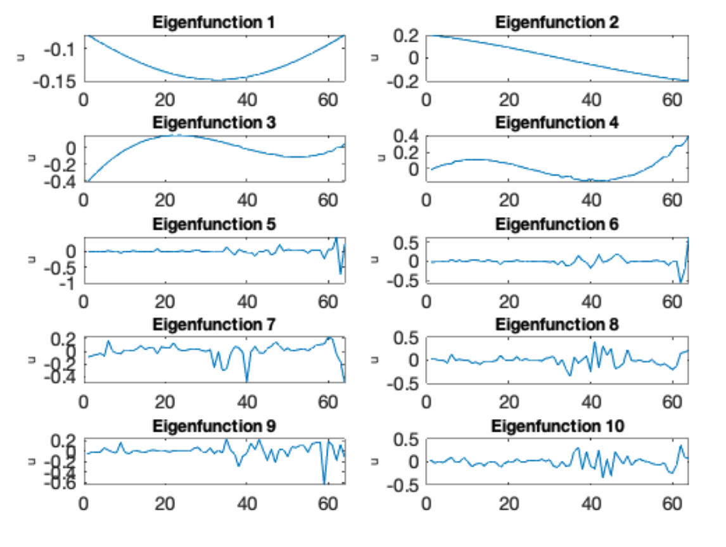

*Figure 2.1.5: Eigenvalues as a function of iteration*

We notice that the first 3-4 eigenfunctios are capturing some of the larger trends in the data and the later ones may be capturing short periods or noise.

d)

Finally we plot the following

Gappy data – Figure 2.1.6

Recovered Data – Figure 2.1.7

Original Data – Figure 2.1.8

Error between original and gappy data – 2.1.9

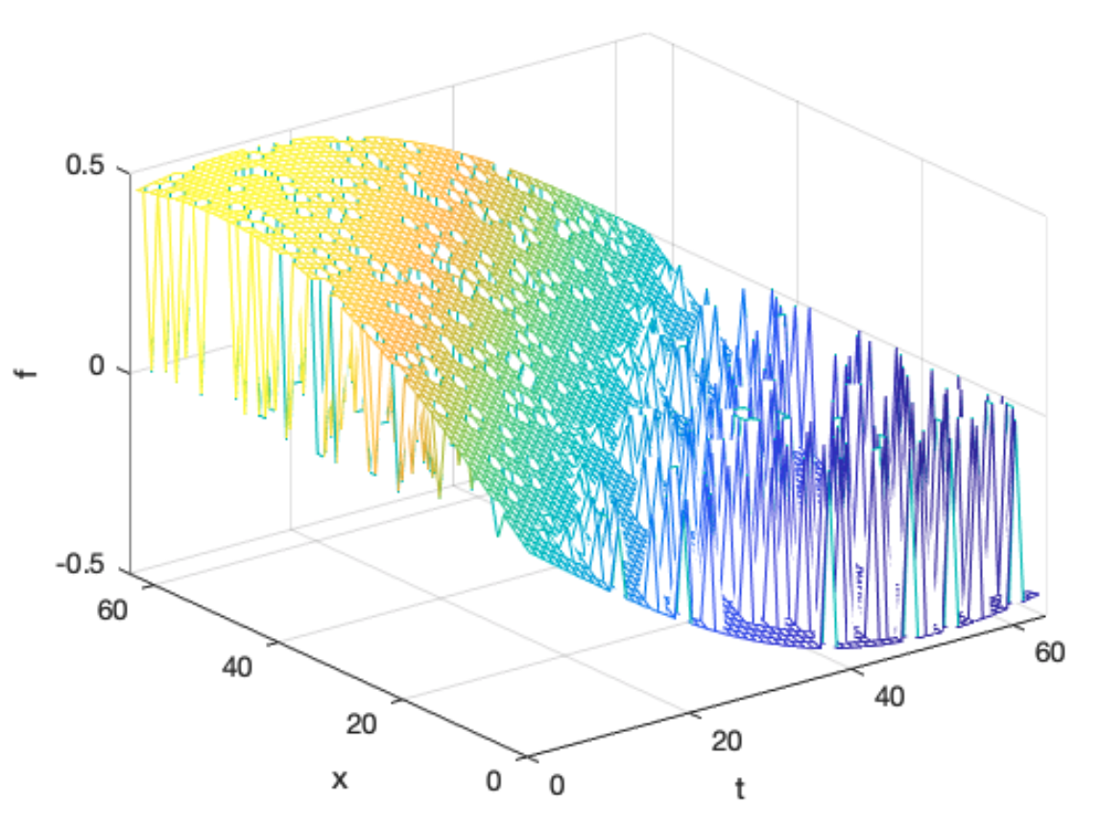

*Figure 2.1.6: Gappy Data*

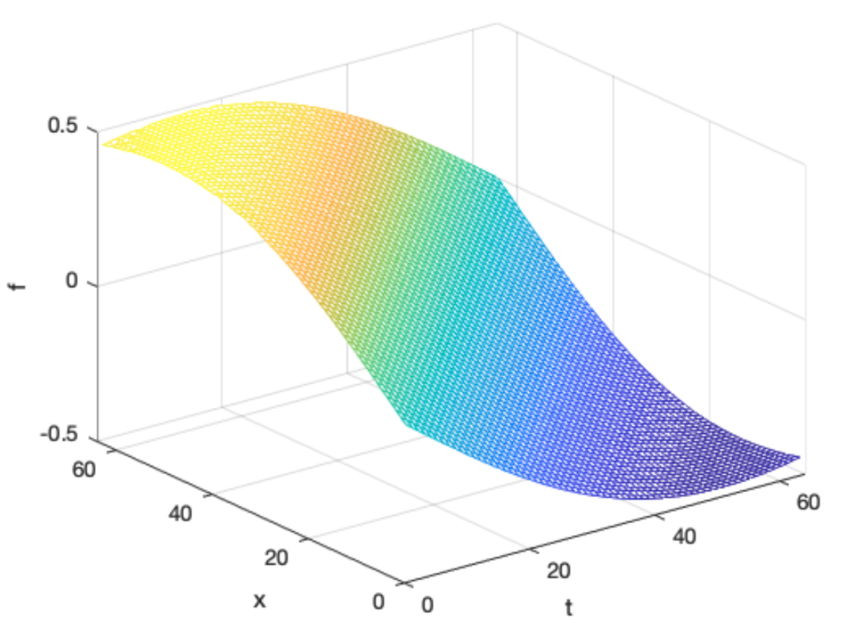

*Figure 2.1.7: Recovered Data*

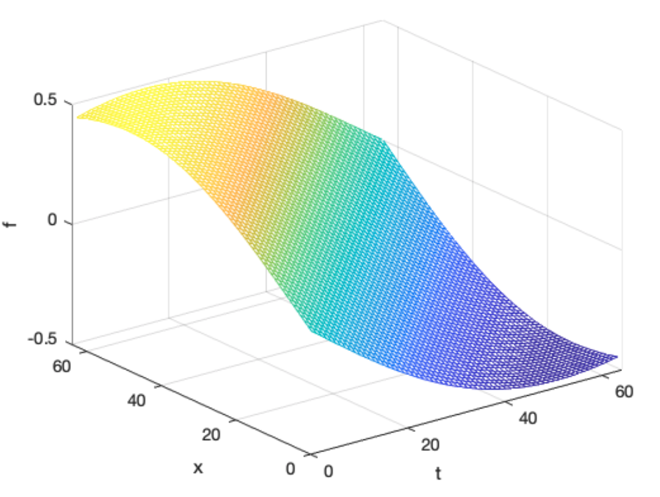

*Figure 2.1.8: Original Data*

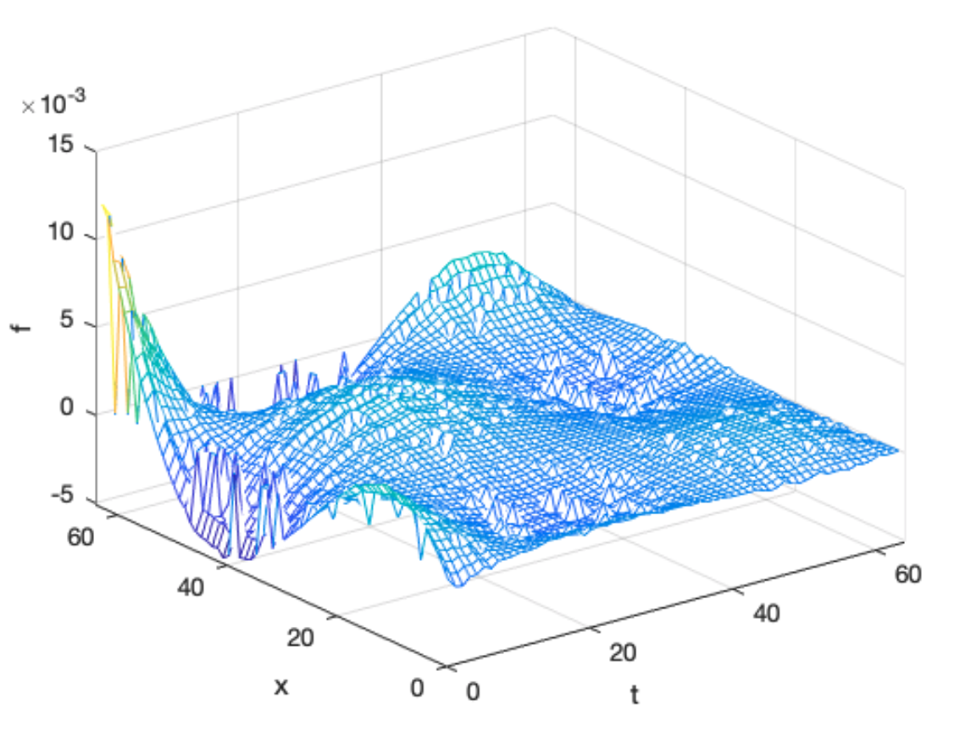

*Figure 2.1.9: Error between original and gappy data*

**2.2 Problem 2**

Since as per the fisher criterion:

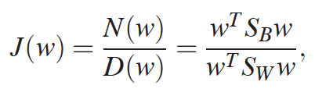

Which reduces to the generalized eigenvalue problem

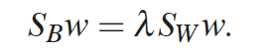

Where SB and SW are the between class and within class scatter matrices. Based on this problem, the size of these matrices are very big (of the order of ~20k), which makes the svd to run very very slow on a personal computer.

For that reason, we formulate an equivalent generalized eigenvalue problem as follows:

Since 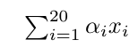, then

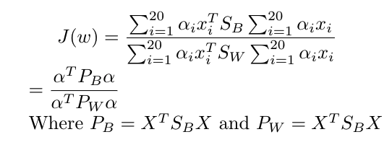

Here PB and PW are 20x20 matrices.

So we can now solve the generalized eigenvalue problem:

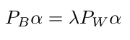

We can get PB by just getting

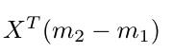and multiplying with its transpose which is a much lower dimensional matrix. Similary we can get PW

We then first read in the data and compute centers m1 and m2.

We then calculate PB and PW as follows:

We calculate M as follows

 and then PB

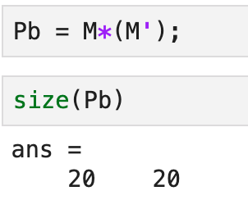

Followed by PW

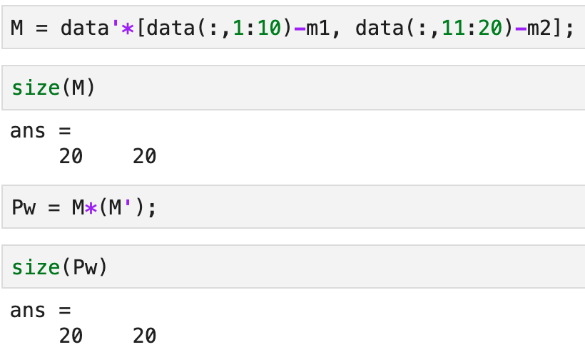

Finally we solve the generalized eigenvalue problem:

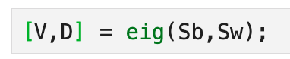

Figure 2.2.1 shows the eigenvalues

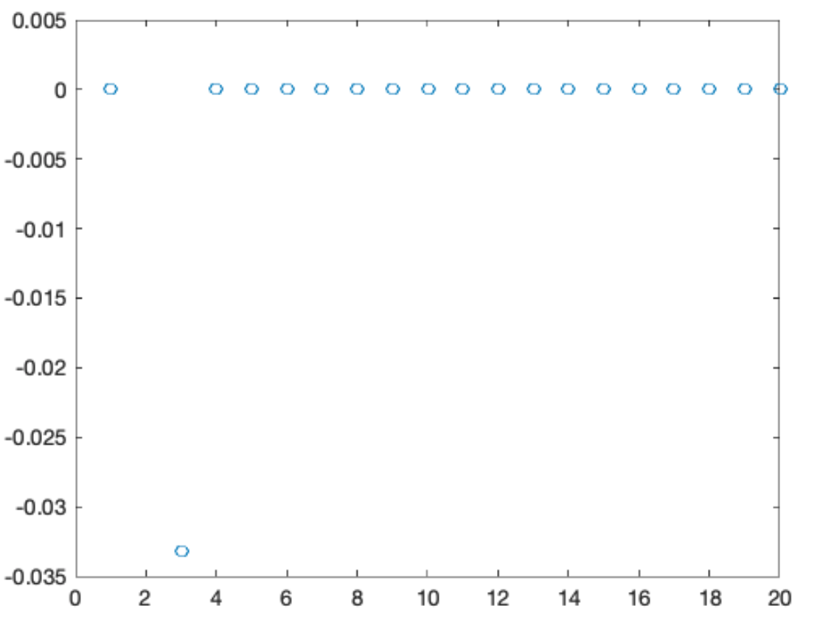

*Figure 2.2.1: Eigenvalues*

We notice that the 2nd eigen values has most of the energy. Therefore we project the data on the 2nd eigenvector (line).

Figure 2.2.2 shows that the classes are well separated

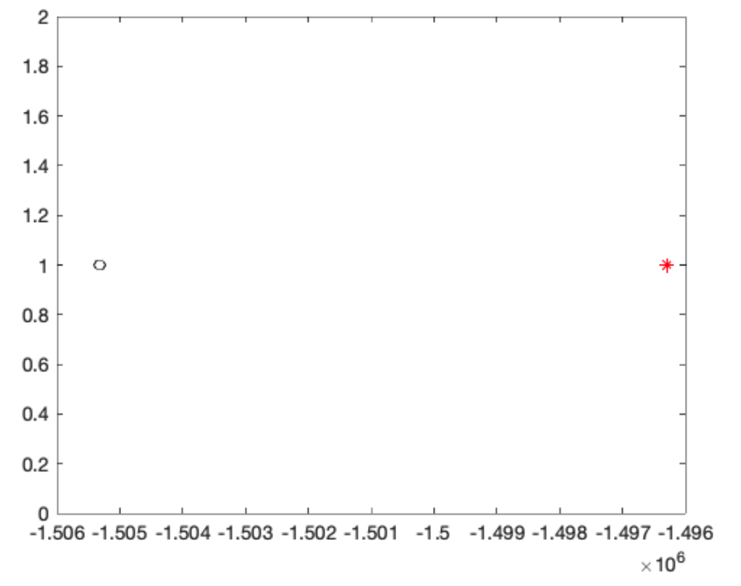

*Figure 2.2.2: Classes are well separated after projection*

We notice that the classes are well separated and hence this projection successfully linearly sepearated both classes using the feature set.

**2.3 Problem 3**

We create a 250 dim vector and from that create 10 signals as follows:

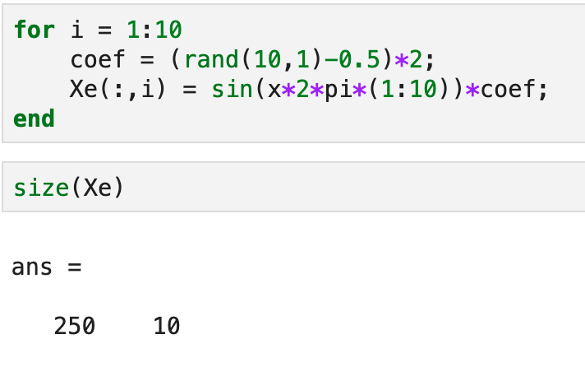

*Code snippet 2.3.1: Create 10 signals of length 250*

The 10 original signals are plotted in figure 2.3.1

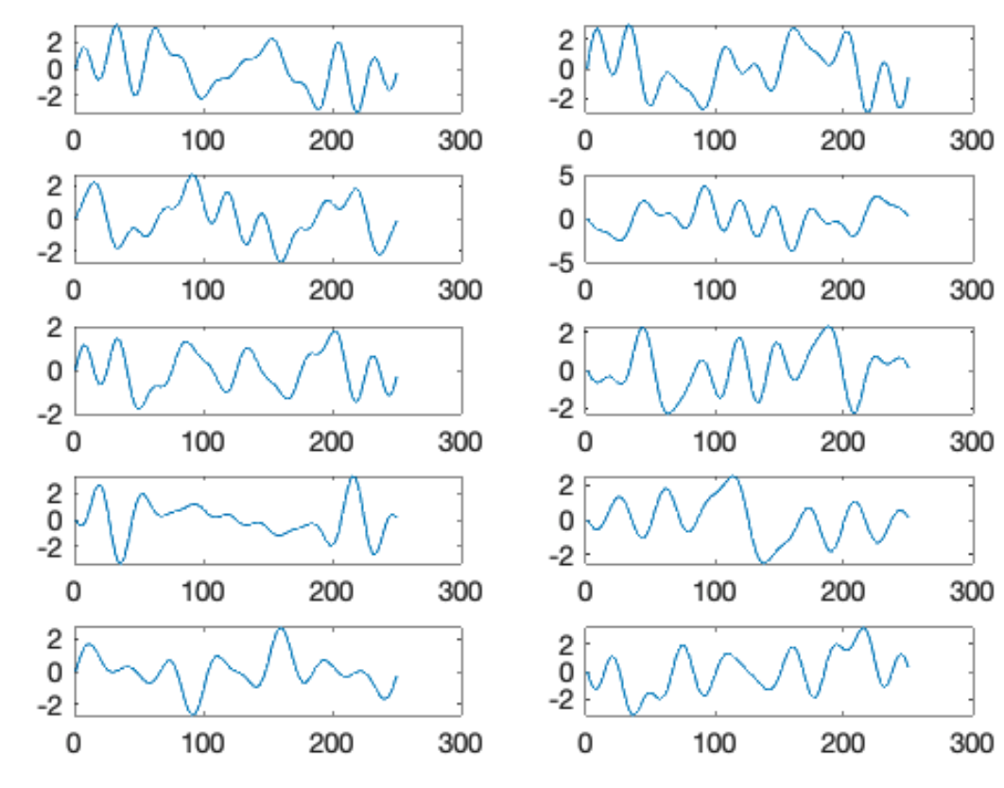

*Figure 2.3.1: Original signal*

We then create correlated signal of rank 3 and add to original signal as follows:

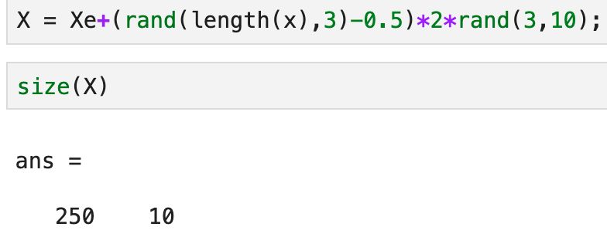

*Code snipped 2.3.2: Creating noisy signal with noise of rank 3*

We then plot the noisy signal as shown in figure 2.3.2

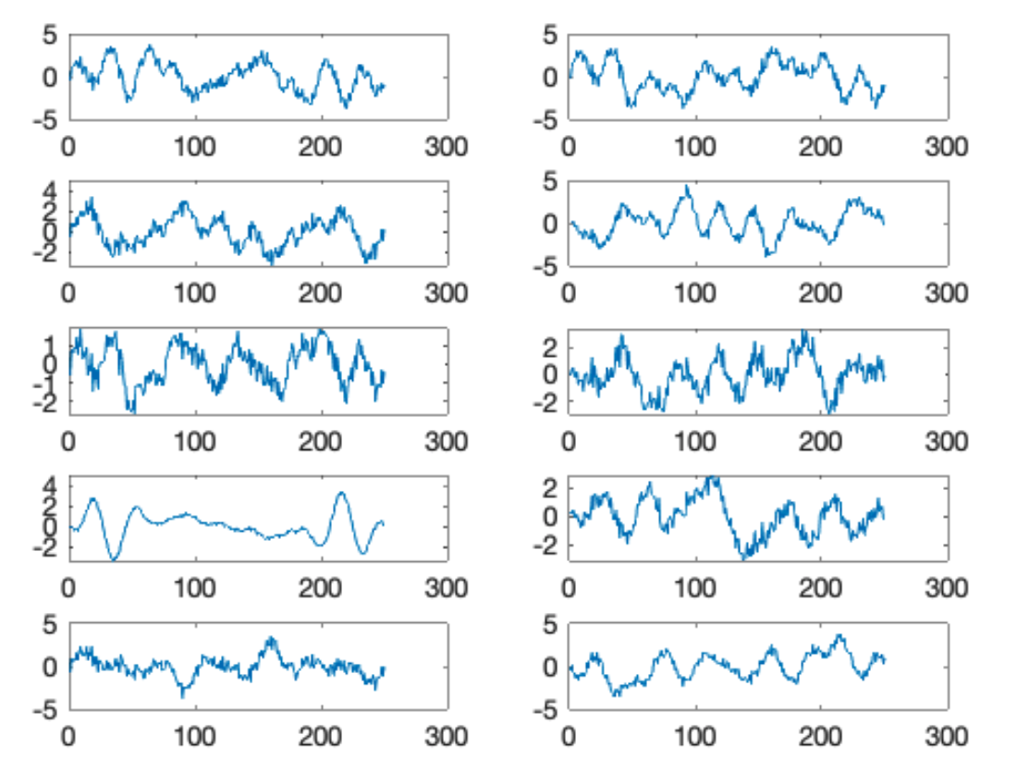

*Figure 2.3.2: Noisy signal*

We then estimate the noise by taking derivative as follows:

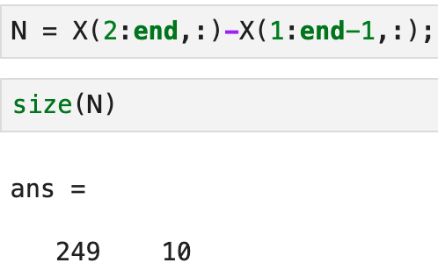

Then we use the matrix N and X to solve the generalized eigenvalue problem:

The eivenvalues are plotted in figure 2.3.3

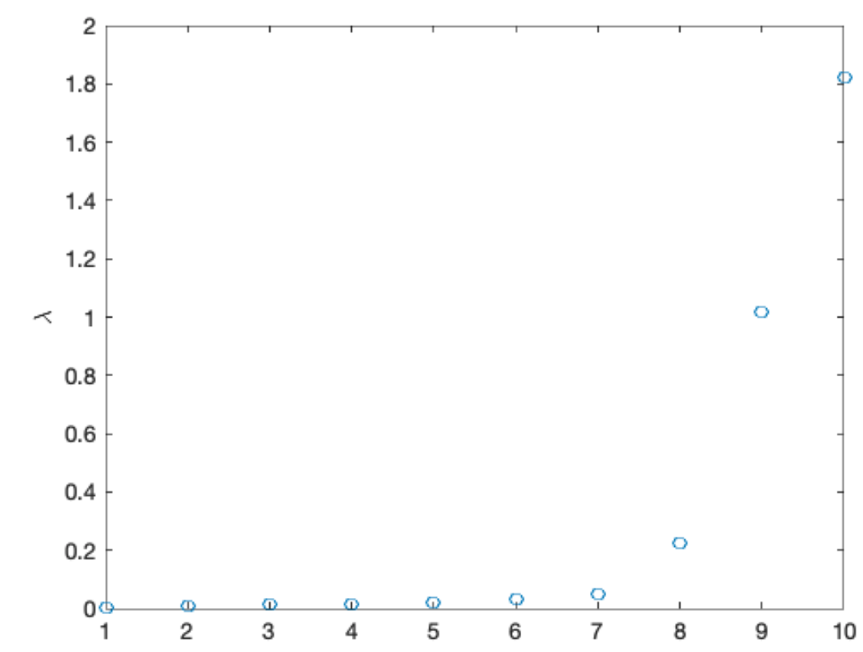

*Figure 2.3.3: Eigenvalues*

We notice that the first 3 large eigenvalues correspond to the signal. So to recover the signal, we just need the first 7 eigenvalues in terms of the smallest magnitude.

We then calculate φ as :

φ= Xψ

And then the recovered signal

$$Y= {}^{T}X$$

Where φ can be the first 7 smallest eigenvalues of the KL basis φ.

We then plot the filtered data, original data and noisy data for all values of D where D goes from 1 to 10.

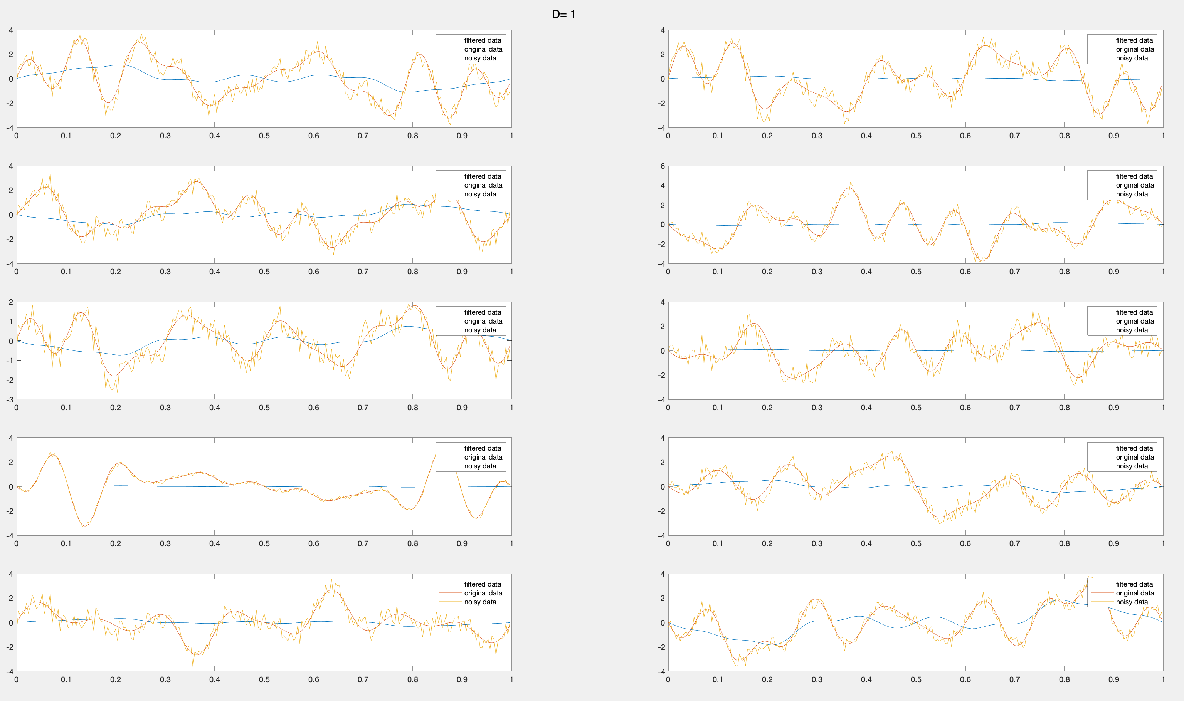

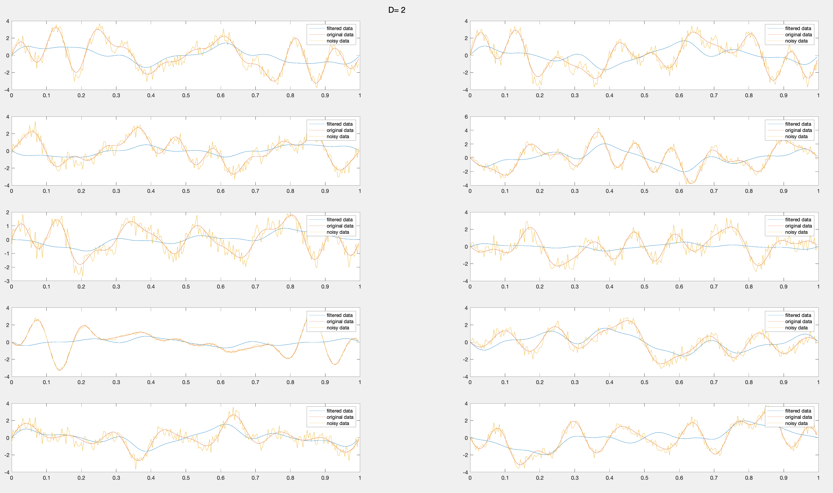

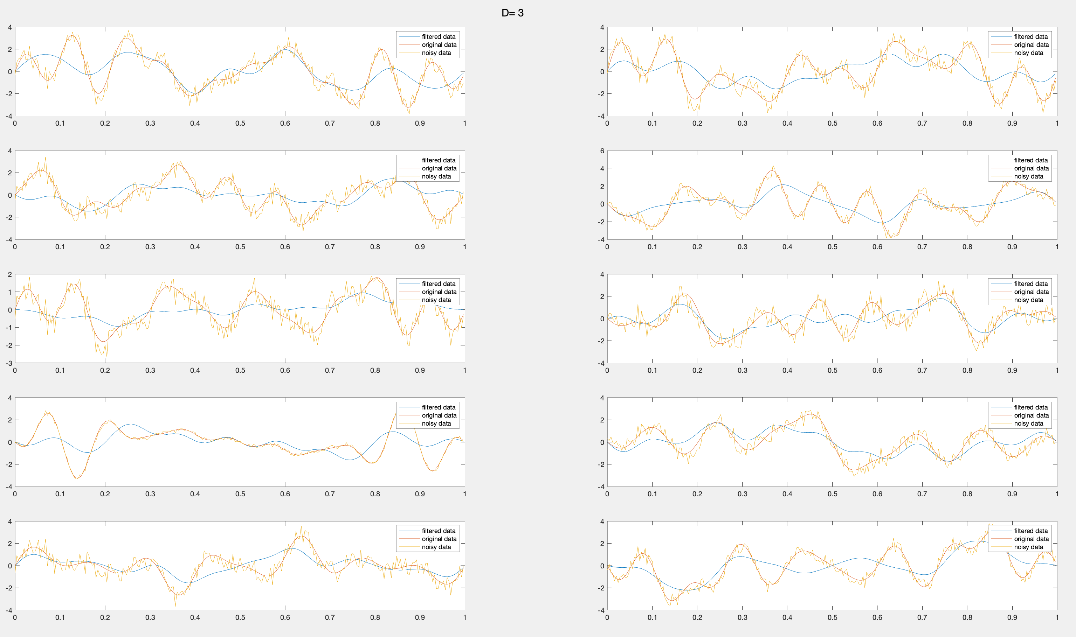

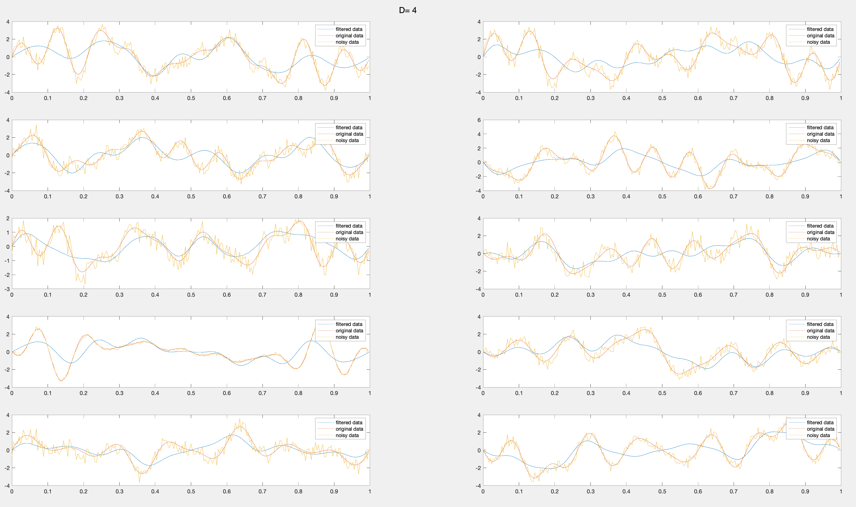

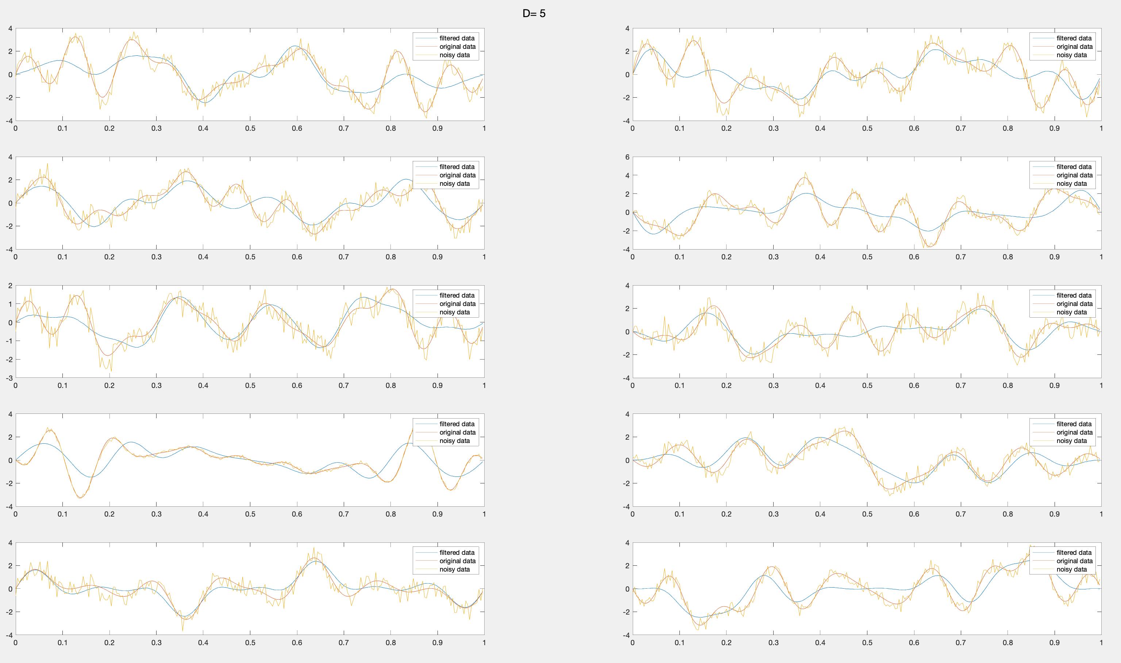

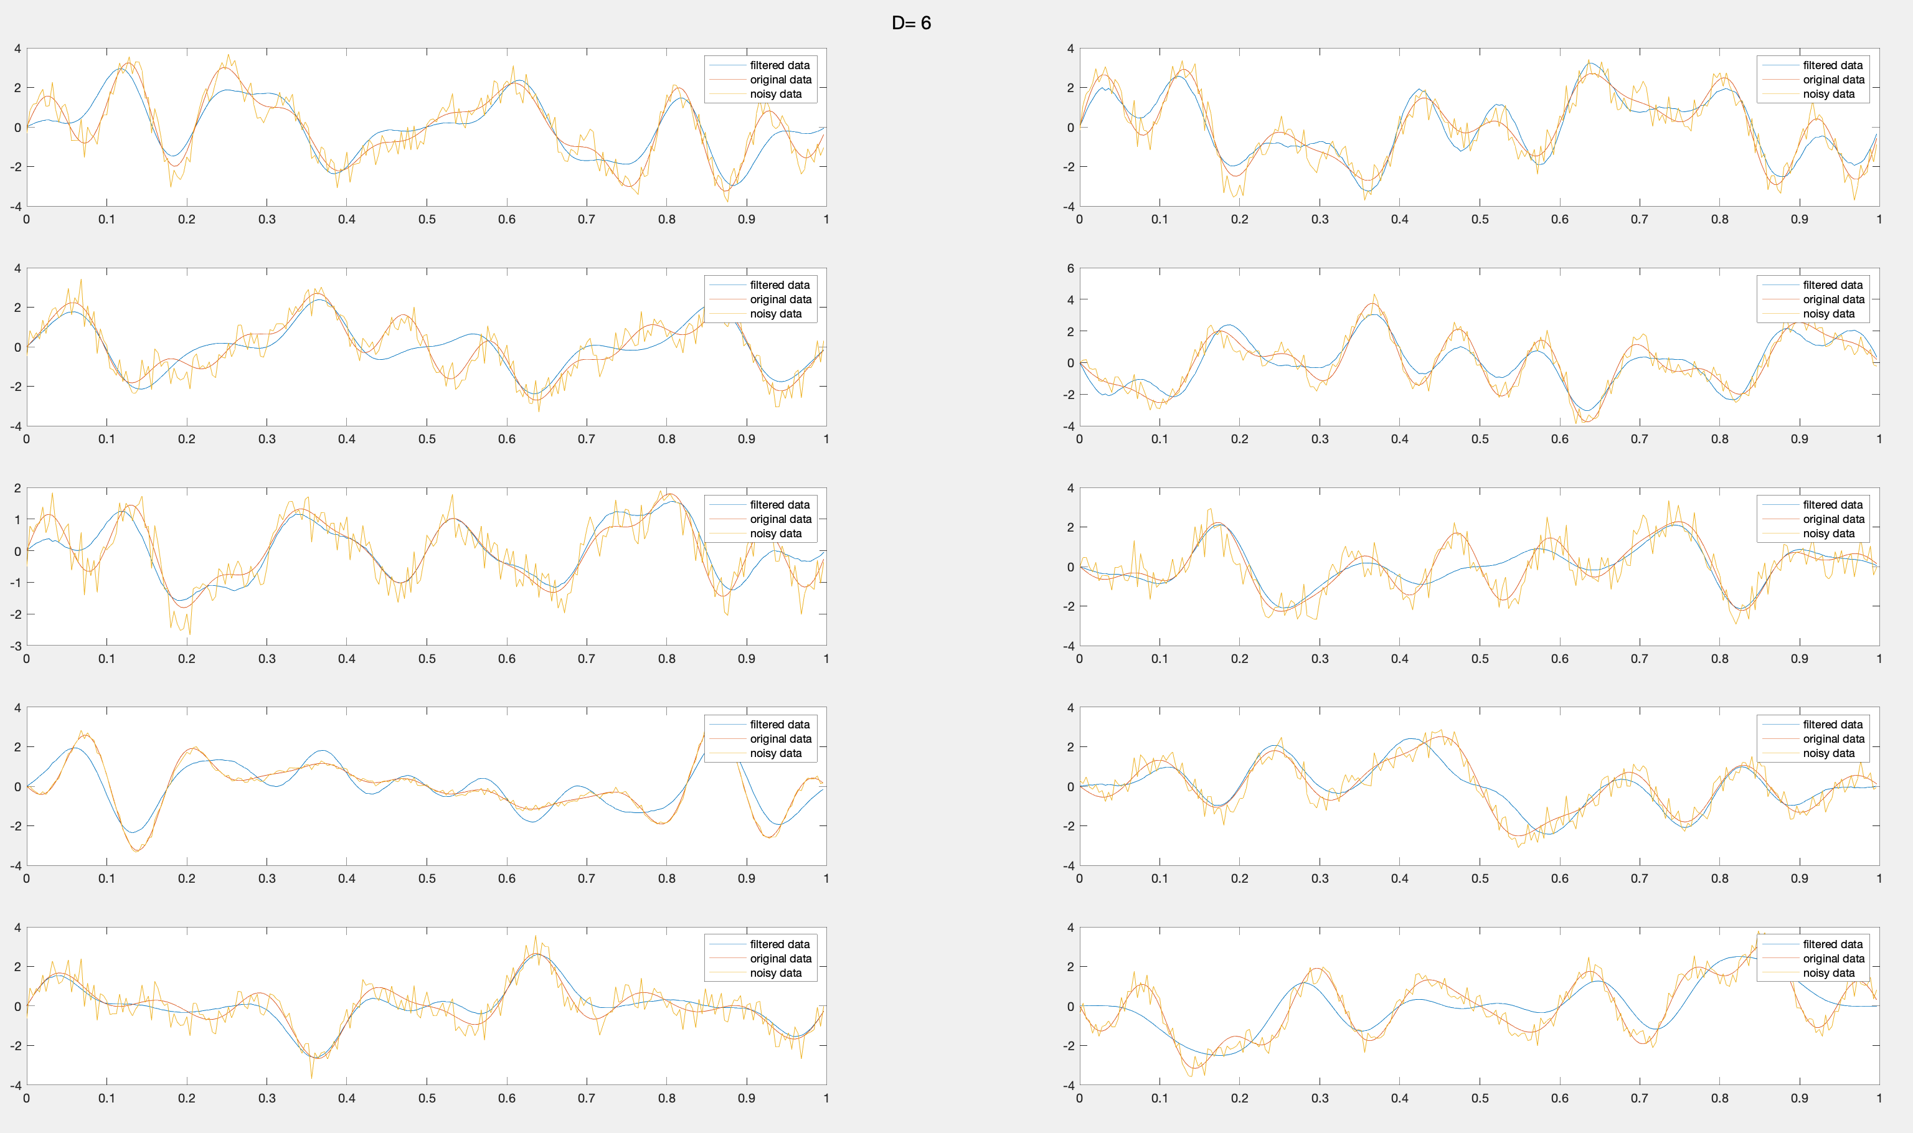

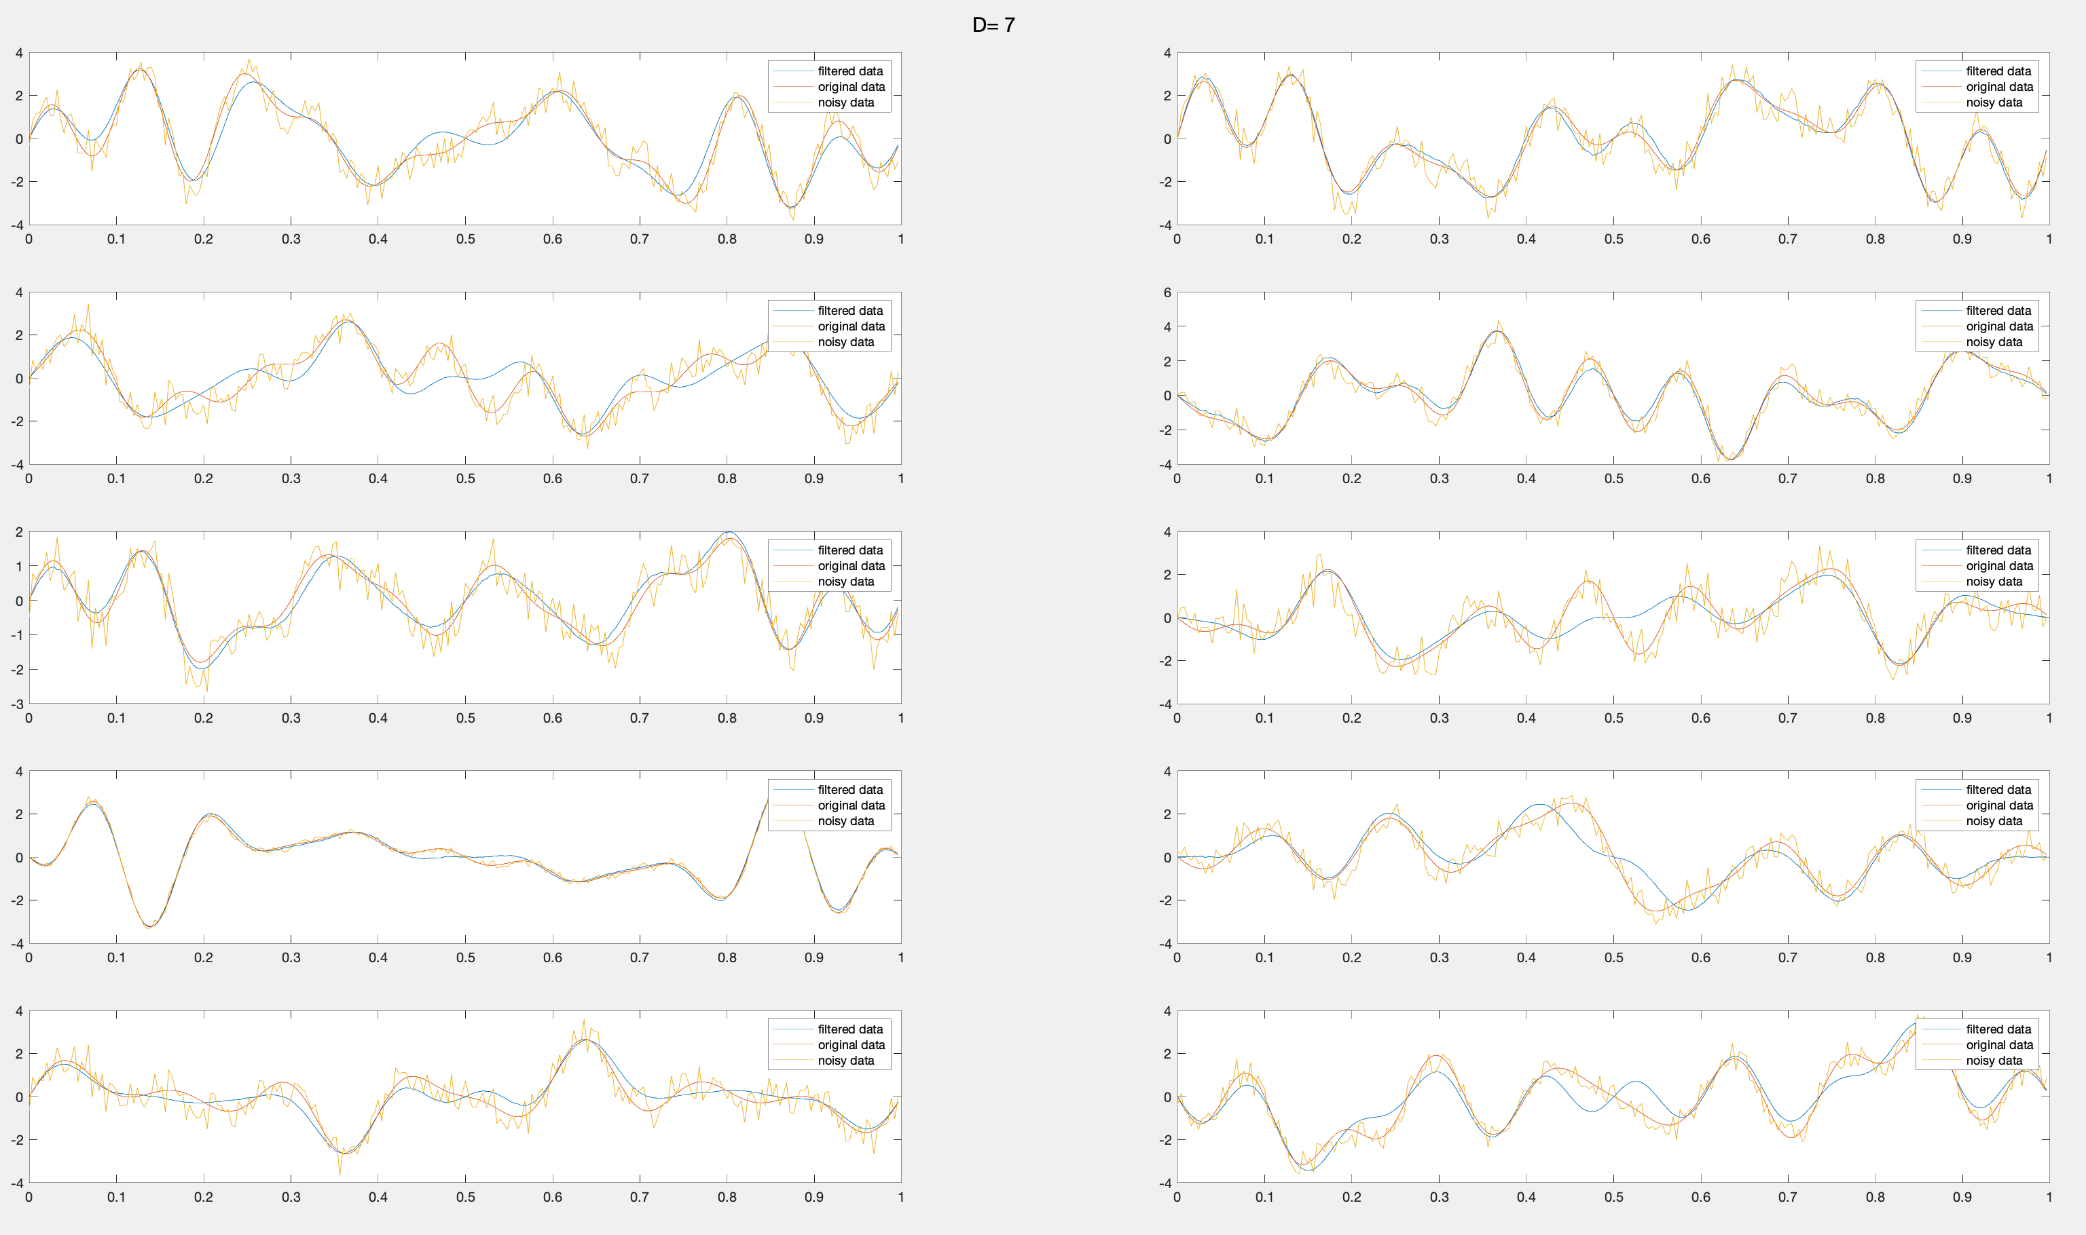

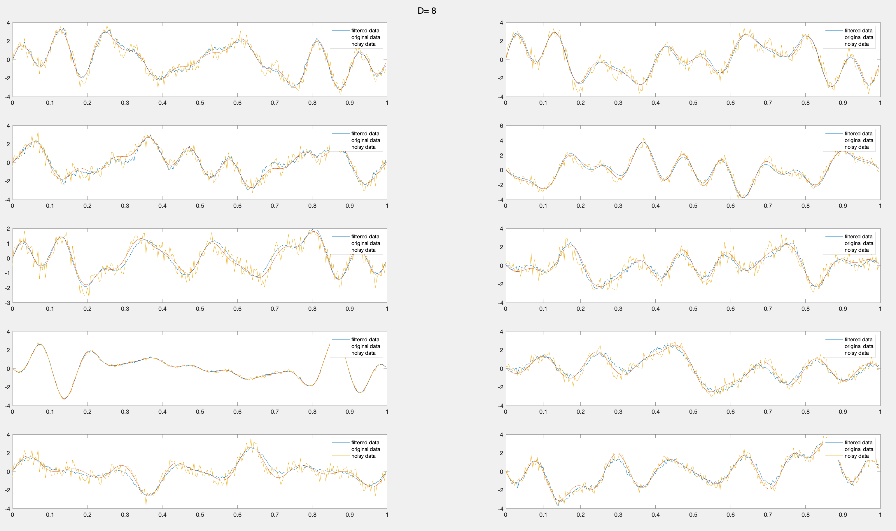

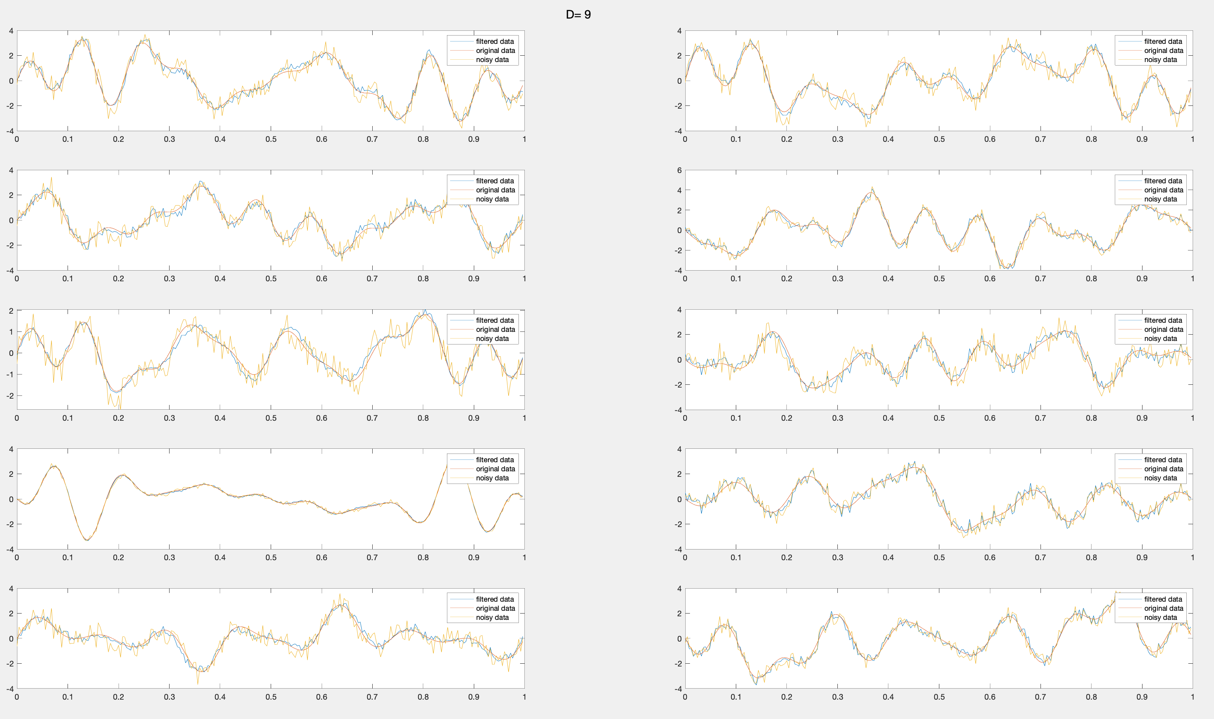

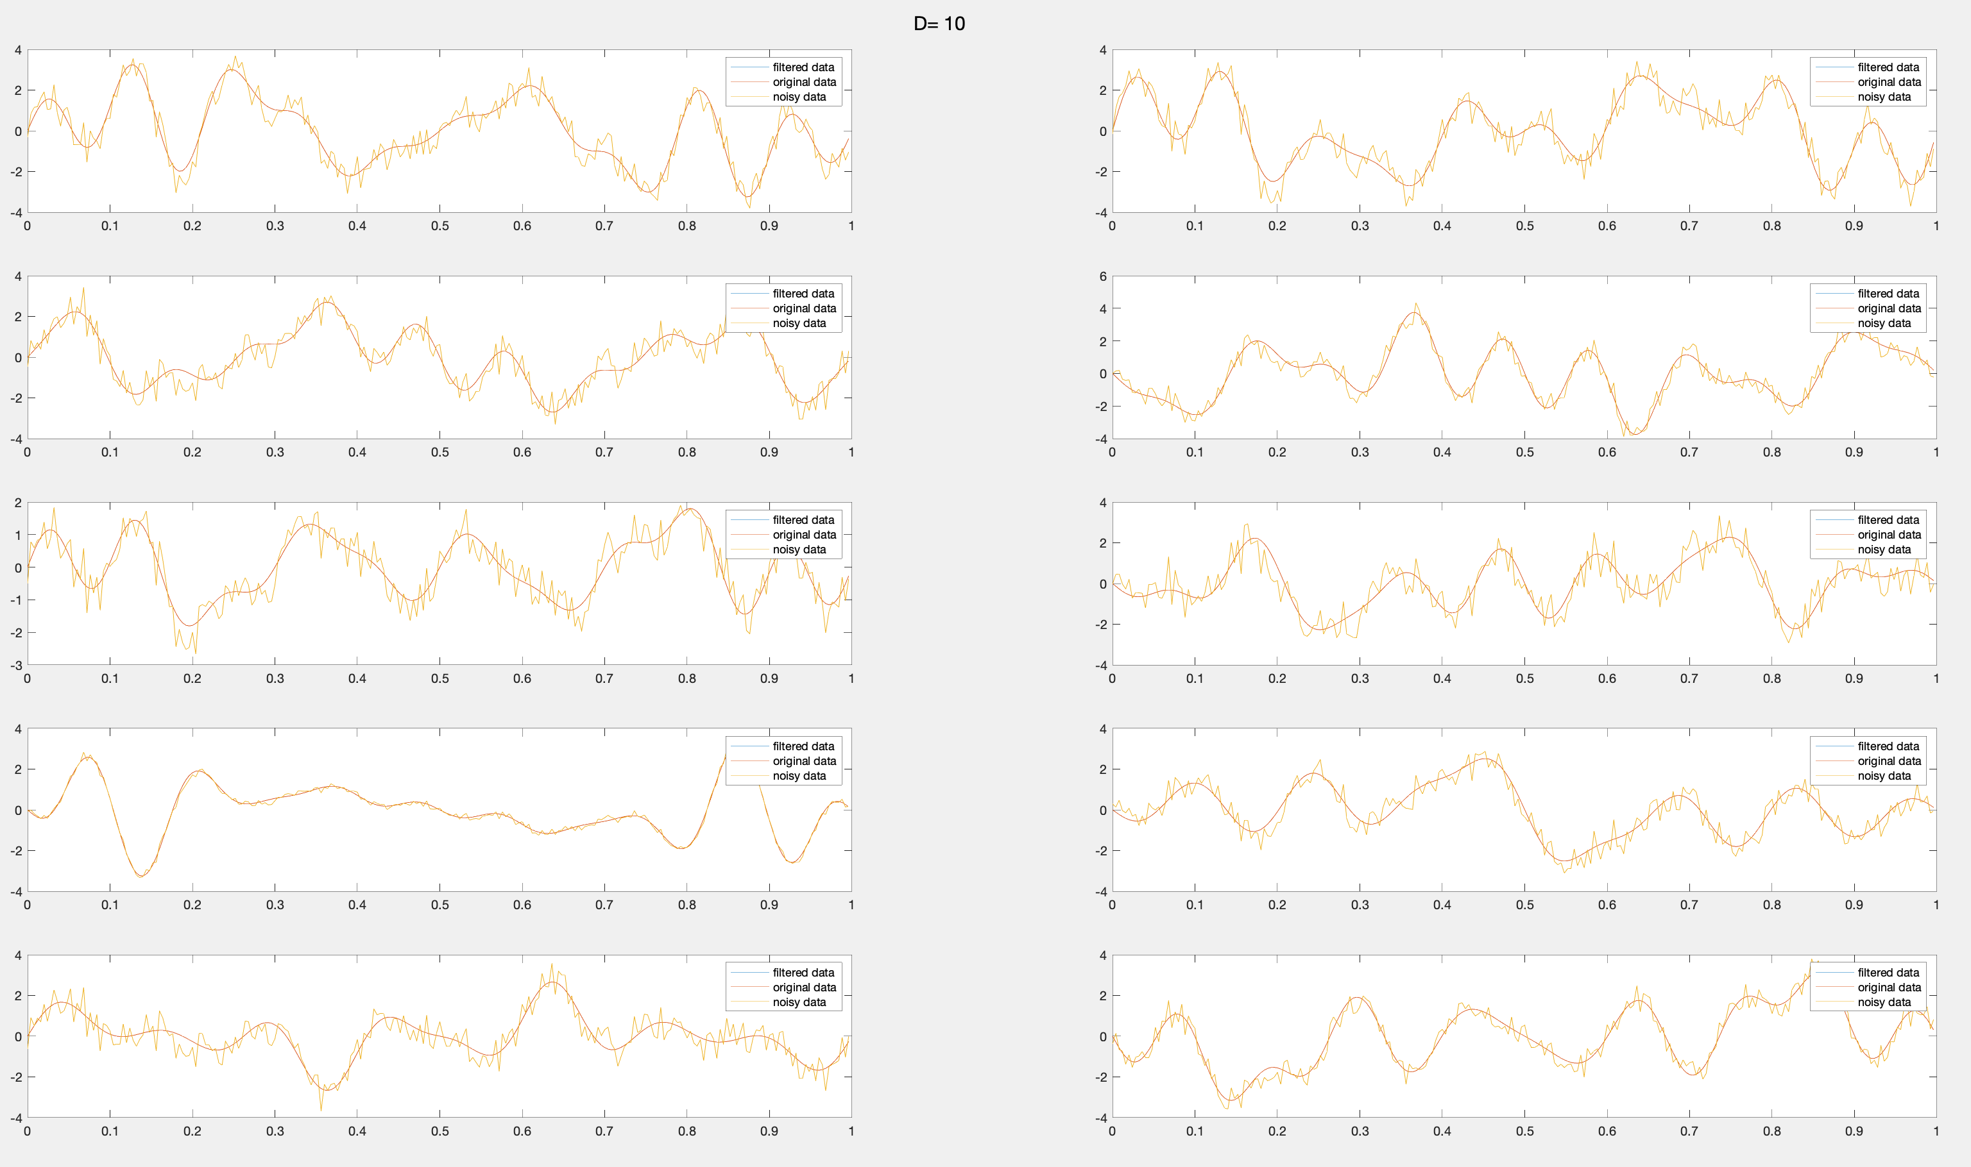

We notice at D=7, we get the best result as the filter data follows the trend of original data without much noise. Where as at D=1 there is no noise but the filtered data has a different trend and at D=10 it exactly matches the noisy data.

**2.4 Problem 4**

We load the image she visualize it:

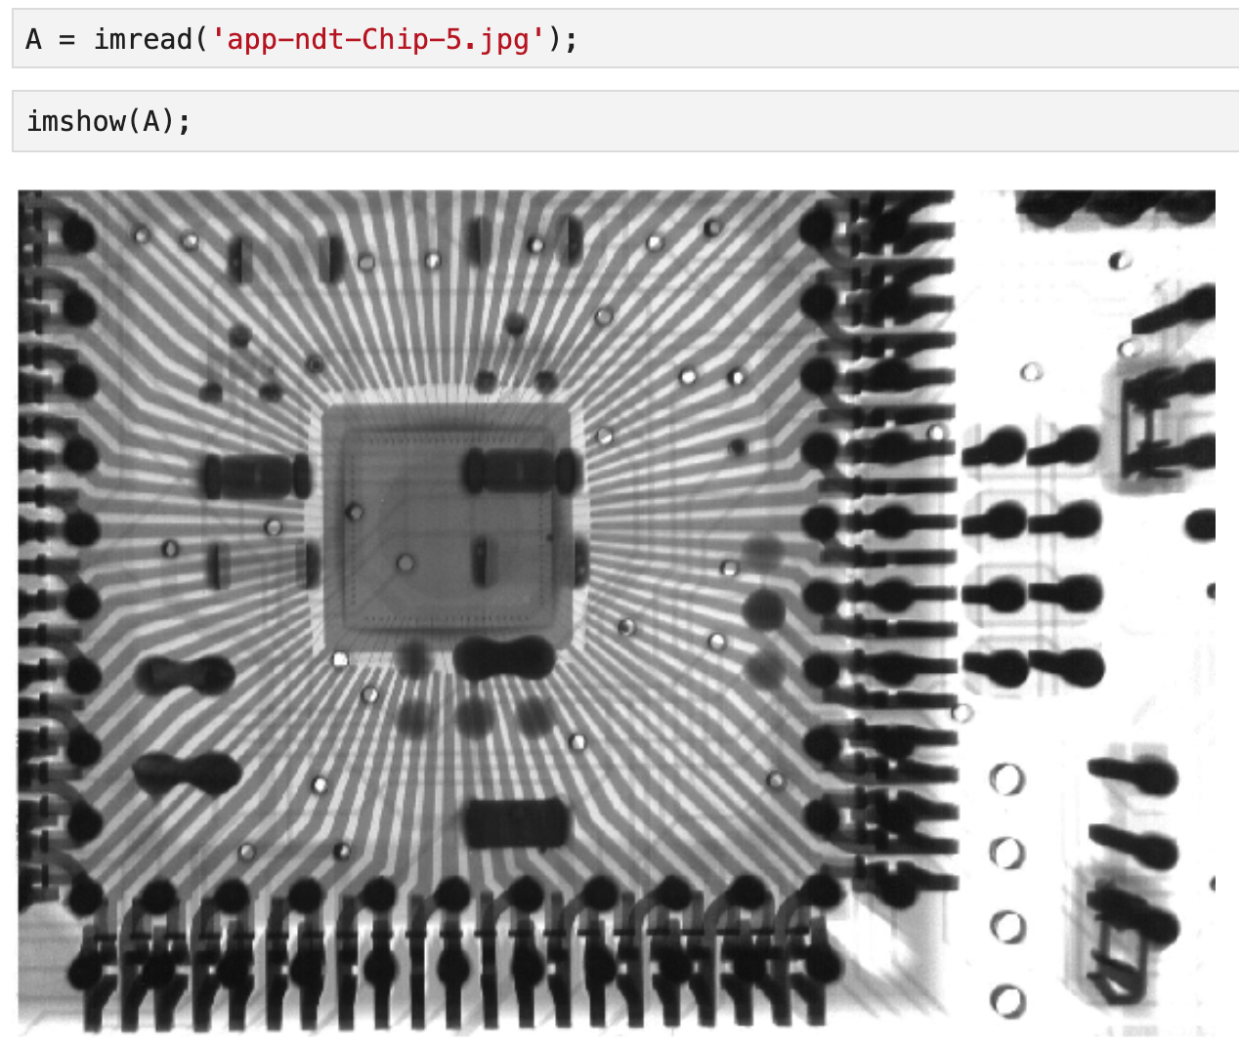

*Figure 2.4.1: The original image*

We then add 40% salt and pepper noise to the image:

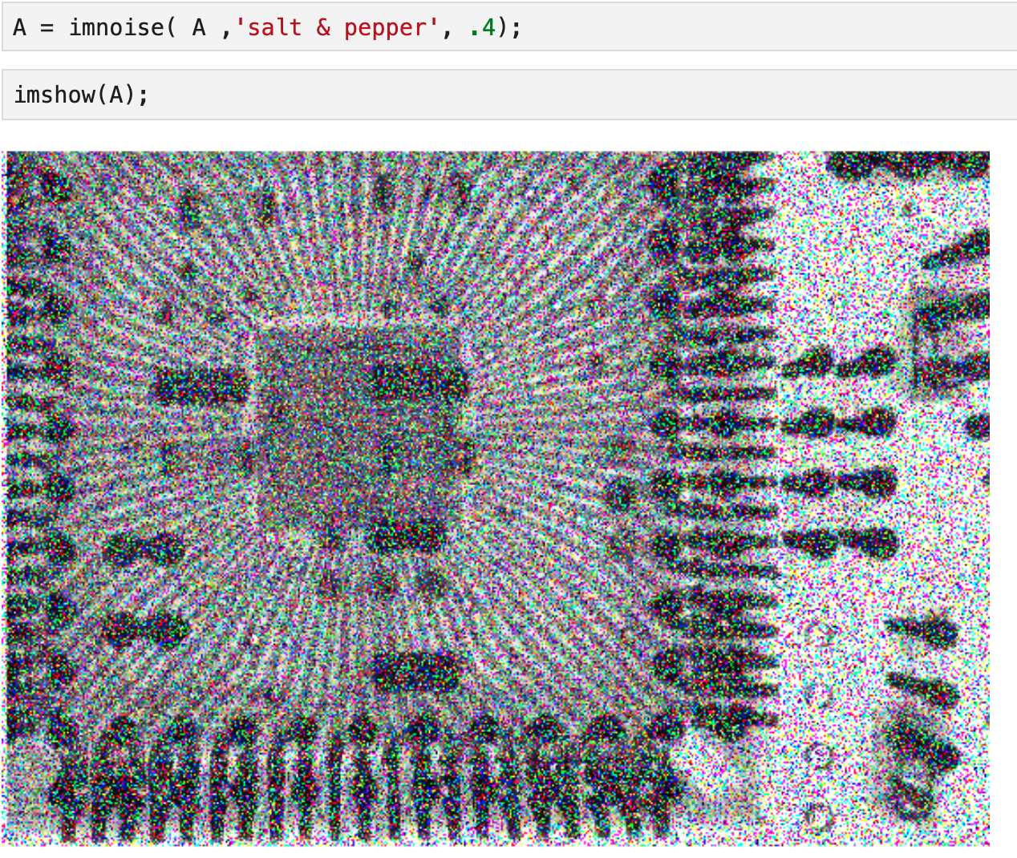

*Figure 2.4.2: The image with salt and pepper noise*

We then apply a 3x3 median filter as follows:

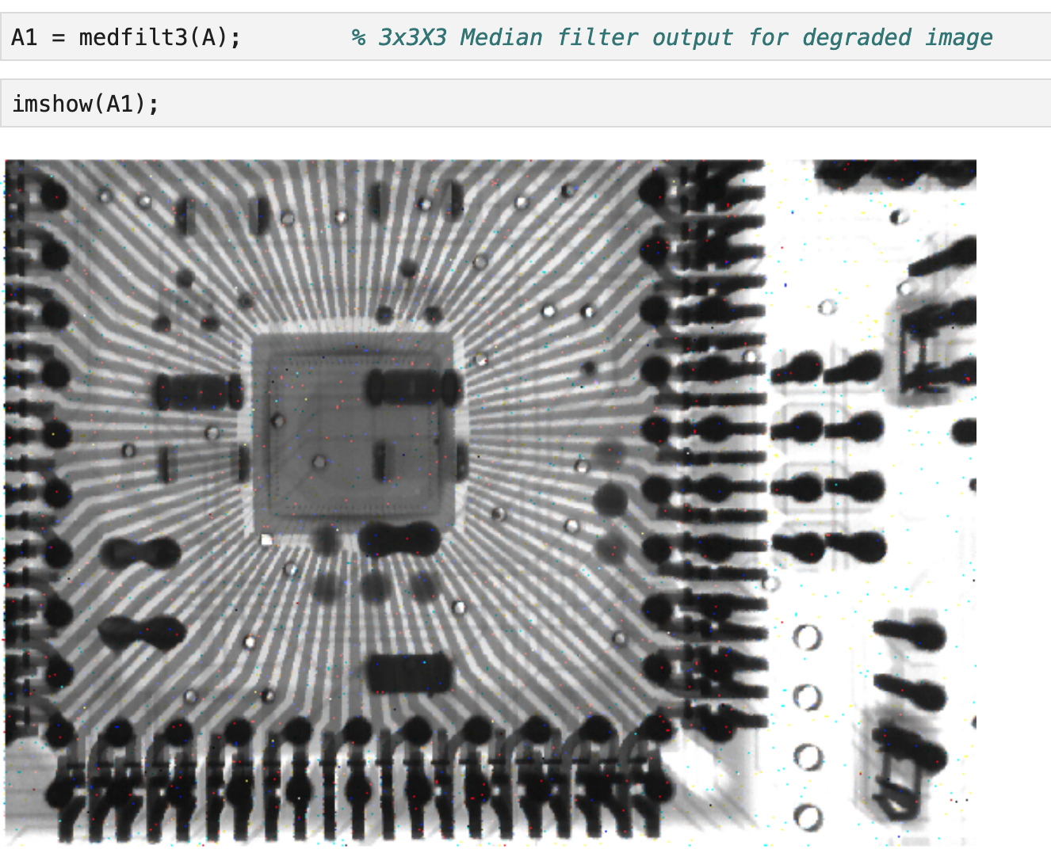

*Figure 2.4.3: After applying 3x3 median filter*

We notice that there are still some lingering noise.

We then apply a bigger 5x5 media filter.

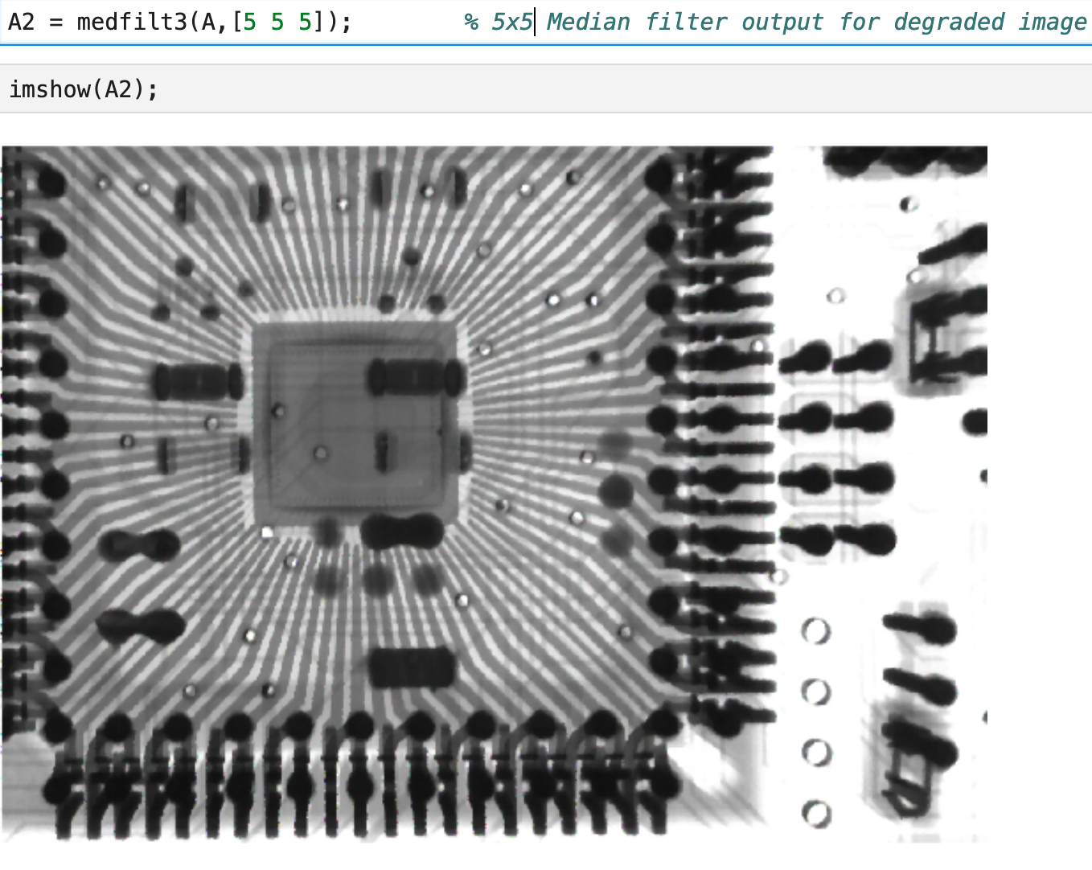

*Figure 2.4.4: After applying 5x5 median filter*

As expected, the noise is completely gone and the output looks like the original image.

**2.5 Problem 5**

We load the original image and display it.

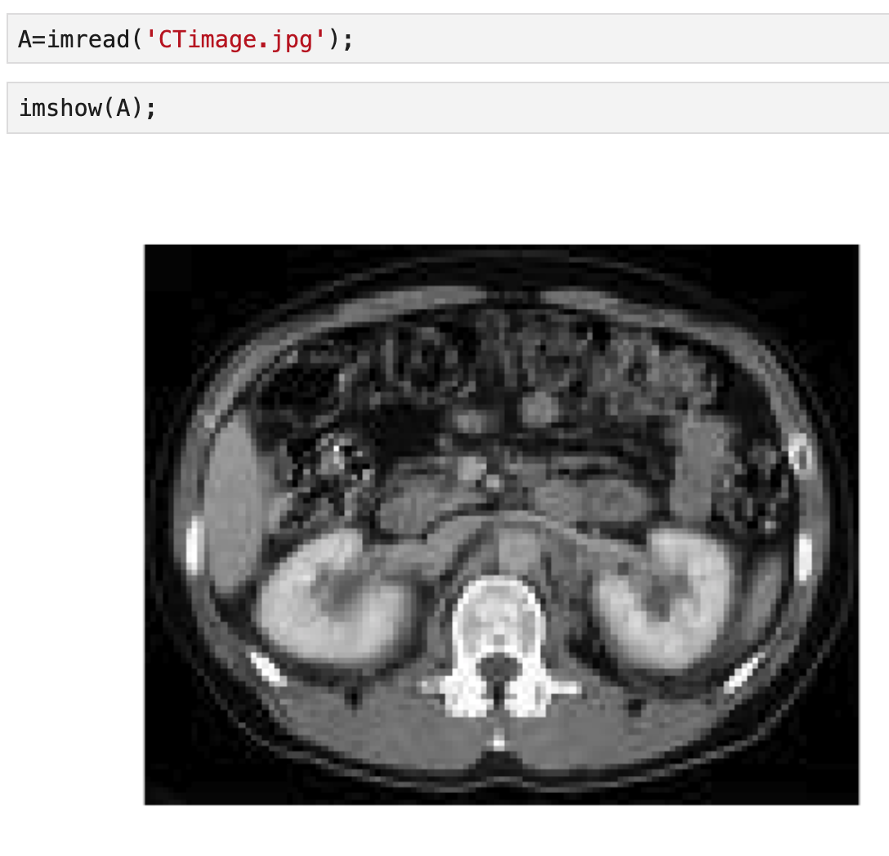

*Figure 2.5.1: Original image*

The image looks pixalated and not very sharp.

We then smooth the image by applying a 3x3 average filter as follows:

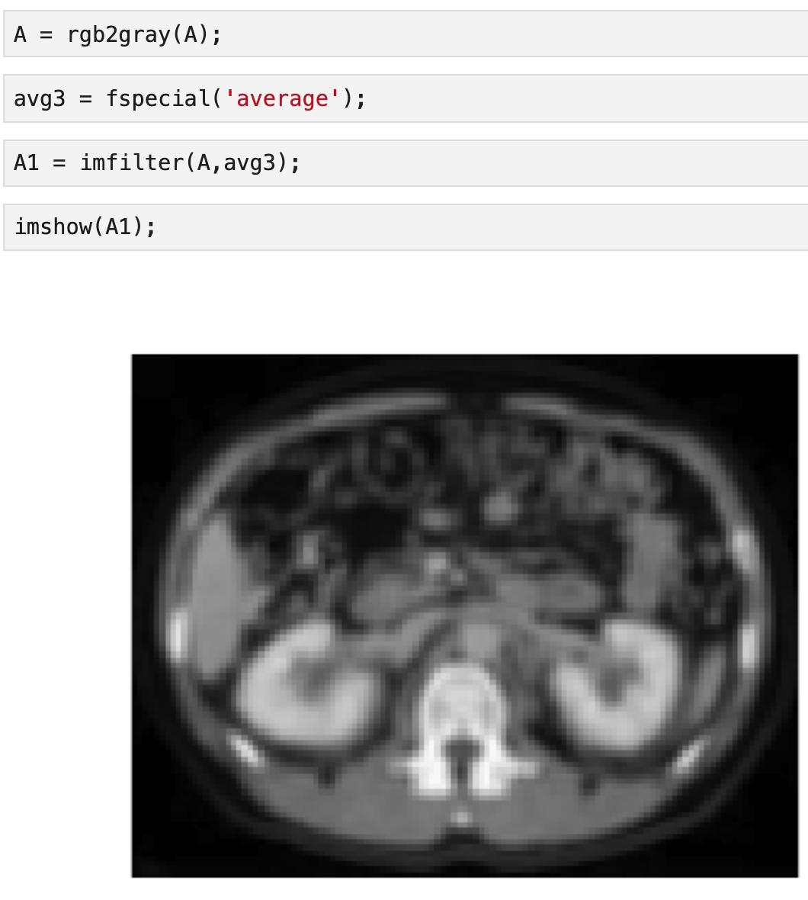

*Figure 2.5.2: Blurred image after 3x3 average filter*

We then construct the Laplacian filter and visualize it.

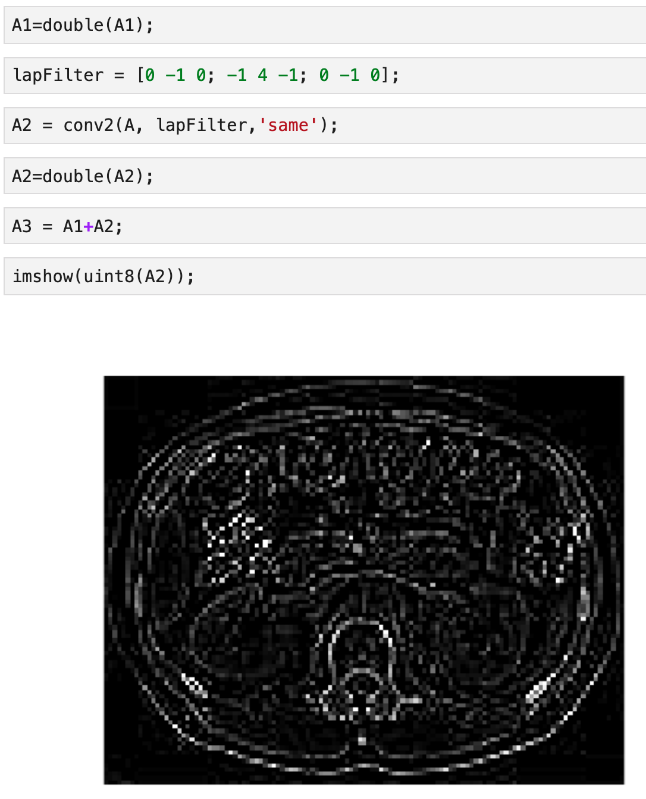

*Figure 2.5.3: After applying the Laplacian filter*

We then add the above image to the blurry image to sharpen the image.

The image looks much more sharpened as shown below.

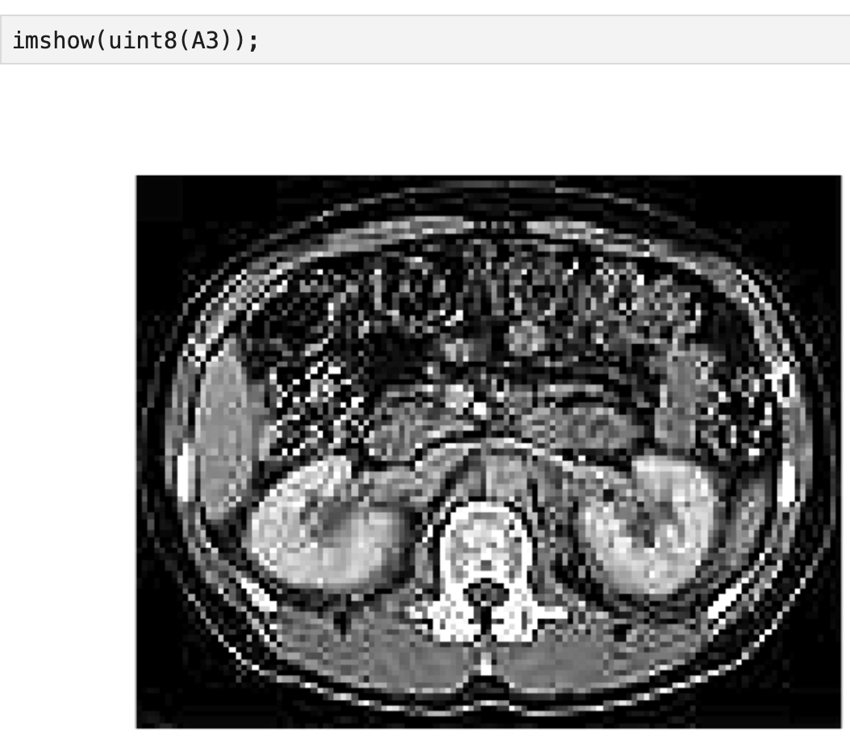

*Figure 2.5.4: Sharpened image.*

We notice that the resulting image looks much more sharpened than the original and hence easier to read.